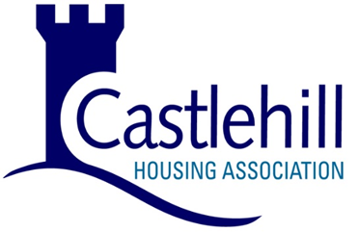

AIDS FOR PERSONS WITH DISABILITIES: SUPPLY TO AN INDIVIDUAL

Name:
Address:
Home Phone No:
Mobile Phone No:
Email Address:

I declare that I am chronically sick or disabled by way of (please specify):

and that I am receiving from

Castlehill Housing Association (Aberdeen Care & Repair)

the following alterations to my private residence

Installation of

at an approximate cost of

£

and I claim that the supply of these goods or services is eligible for relief from Value Added Tax under Group 14 of the Zero Rate Schedule to the Value Added Tax Act 1983.

Signature:

Date:

NB Signing this VAT exemption form is authorisation to proceed with the proposed work and agreement of the costs.

